

**Survey on the educational expenditure of public and private university students**

**Mahmud Kabir**

Department of economics

University of Barishal

**Abstract:**

To meet the growing need for increased capacity in higher education, the government of Bangladesh encouraged development of private universities in 1992. Currently, there are sixty private universities, thirty-four public universities and three international universities in Bangladesh. Although the increased number of universities has provided opportunities, a debate has emerged over the quality of education at these institutions due to the significant difference among these institutions. These inconsistencies in quality may be due to the lack of regulatory oversight and inefficiencies of the regulatory agencies of the government. The cost of education at private universities is high compared to the significantly lower cost at public universities that are subsidized by the government. In spite of the higher cost, student satisfaction levels have not been higher at private universities in the past. The work presented in this paper seeks to determine the quality of education in public and private universities in Bangladesh using student satisfaction as a measure of quality. It is well understood that student satisfaction measure may not be the only indicator of quality, but it can be considered as one of the important indicators. The twenty question survey results from private and public university students of Bangladesh were compared to determine the level of student satisfaction. The results derived from this data can be used by both public and private universities for improving quality in higher education.

**Introduction**

Since the 1980’s, there has been a growing trend in higher education to pursue quality management practices in preparation for the business world. In general, university faculty protested against the application of some of the current quality management trends, especially rejecting those that defined students as “customers.” Some of these trends, such as Total Quality Management (TQM), were passing movements but, others are still widely recognized in other industries(Islam et al., 2020). Despite the faculty resistance, interest in applying quality management methodology in higher education continues, perhaps, because of the rise of private universities. Although for-profit universities have existed for quite some time in most developed countries, the unprecedented growth of private universities in the 1990’s and 2000’s has led to more efforts toward quality management in higher education(Korzeniowska & Ulman, 2023). Also, with the rise of private universities has come an effort to determine which type of university, public or private, can provide a higher quality education to students(Dasgupta et al., 2014). It is important to note that, in many cases, university location plays a role in the determination of which type of university prevails. In Canada, for example, public universities are considered to be much more effective than private universities, and are ranked higher in national ratings(Easaw et al., 2013). In Jakarta, Indonesia, private universities are more highly rated(Pannell, 2010). It is also generally agreed that private universities provide more opportunities for an increasing number of students seeking quality higher education. There is a common perception that the cost at private universities is unreasonably high, despite the higher quality(Abdelkhalek & Arestoff, n.d.). However, a previous study of private and public universities in Bangladesh provides preliminary data suggesting that it is possible that students may still be more satisfied with private universities in Bangladesh than with public universities. For example, students at Ahsanullah University of Science and Technology (AUST), a private university, were shown to be more satisfied than students at Chittagong Veterinary and Animal Sciences University (CVASU), a public university(Szopiński, 2017).

**Methodology**

The survey consisted of both closed ended and open ended questions. Data was collected through online surveys and in person interviews. The survey sample included students from different age groups and academic disciplines. A total of 100 students participated in the survey. 34 students were from private university and 66 students were from public students.

**Key Findings**

**Tuition fees:**

On average student attending private University reported higher tuition fees compared to those in public University. Approximately 70% of private University students status that tuition fees significance financial Barden, while 10% of public University students felt the same way. There is very little additional fees in public universities but it is high in private universities.

**Scholarship and Financial Aid:**

Only 12.6% students receive scholarship or financial aid. And 87.4% students do not receive any scholarship or financial aid.

Forms response chart. Question title: Have you received any scholarships or financial aid from your university?
. Number of responses: 103 responses.

**Housing or accommodation:**

Here most of the students wants to pay lower cost for their accommodation. Only 14.6% students pays more than 4000 BDT for their accommodation. Here 36.9% students expenses 1000-2000 BDT for their accommodation. 30.1% students pay 2000-3000 BDT for their accommodation .And only 18.4% pays 3000-4000 BDT for their housing or accommodation. 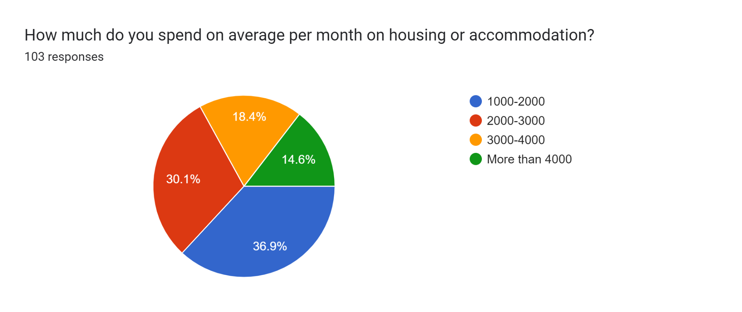

**Quality of education:**

A large number of students believe that the quality of education at your university justifies the expenses incurred**.** Here 57.3% students believe that the quality of education at your university justifies the expenses incurred. Only 13.6% students don not believe that the quality of education at your university justifies the expenses incurred. And 29.1% are in confusion.

Forms response chart. Question title: Do you believe that the quality of education at your university justifies the expenses incurred? 
. Number of responses: 103 responses.

**University Facilities:**

Here maximum student’s satisfaction is medium. 8.7% student’s satisfaction is very lower. Higher satisfaction is also lower. 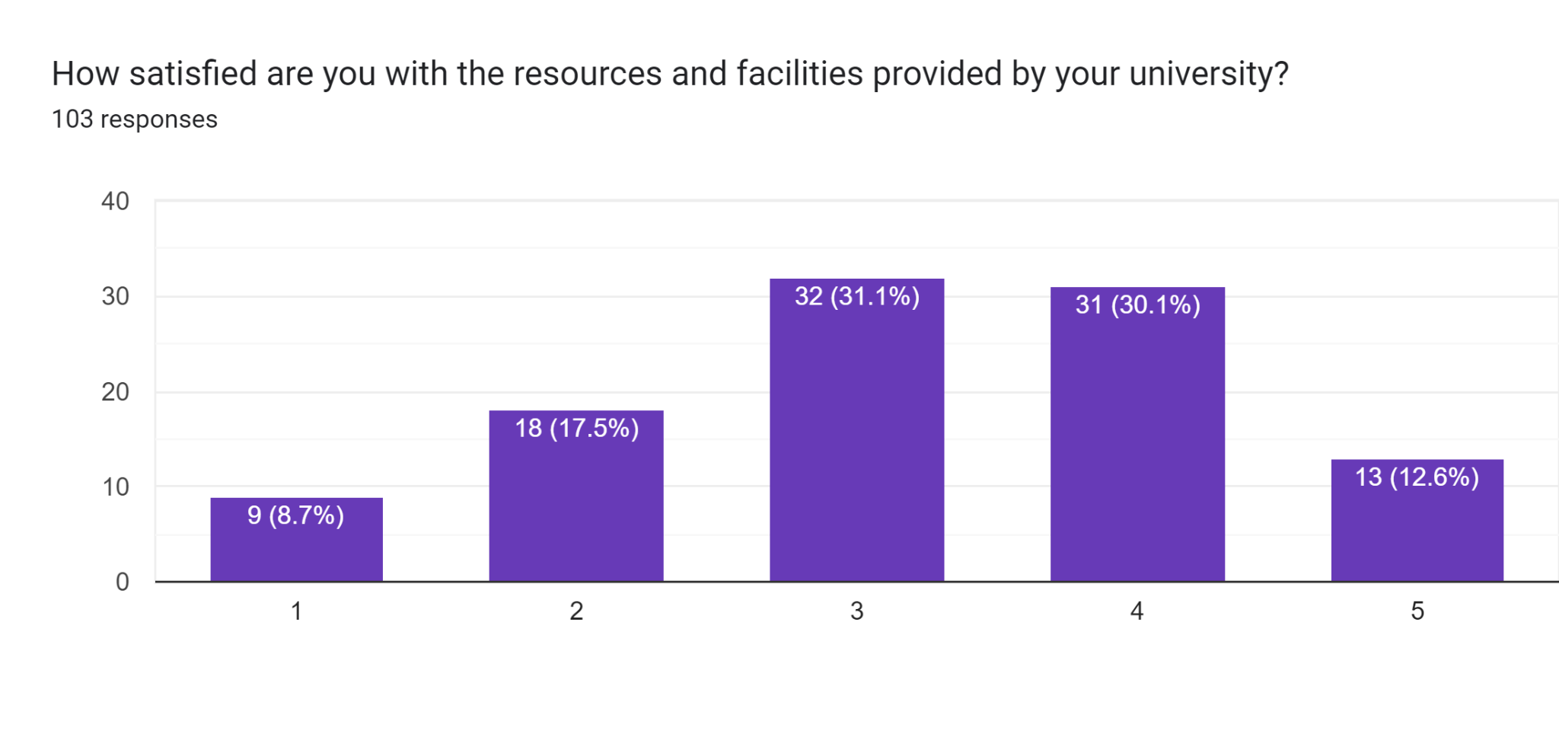

**Part time employment:**

A higher percentage of students worked part time jobs to support their education. Here 26.4% students spend 3-4 hours for tuition or another job. 23.6% students spend 1-2 hours for tuition. That means 50% students are involved in a tuition or part time job. Only 14% students have no tuition.

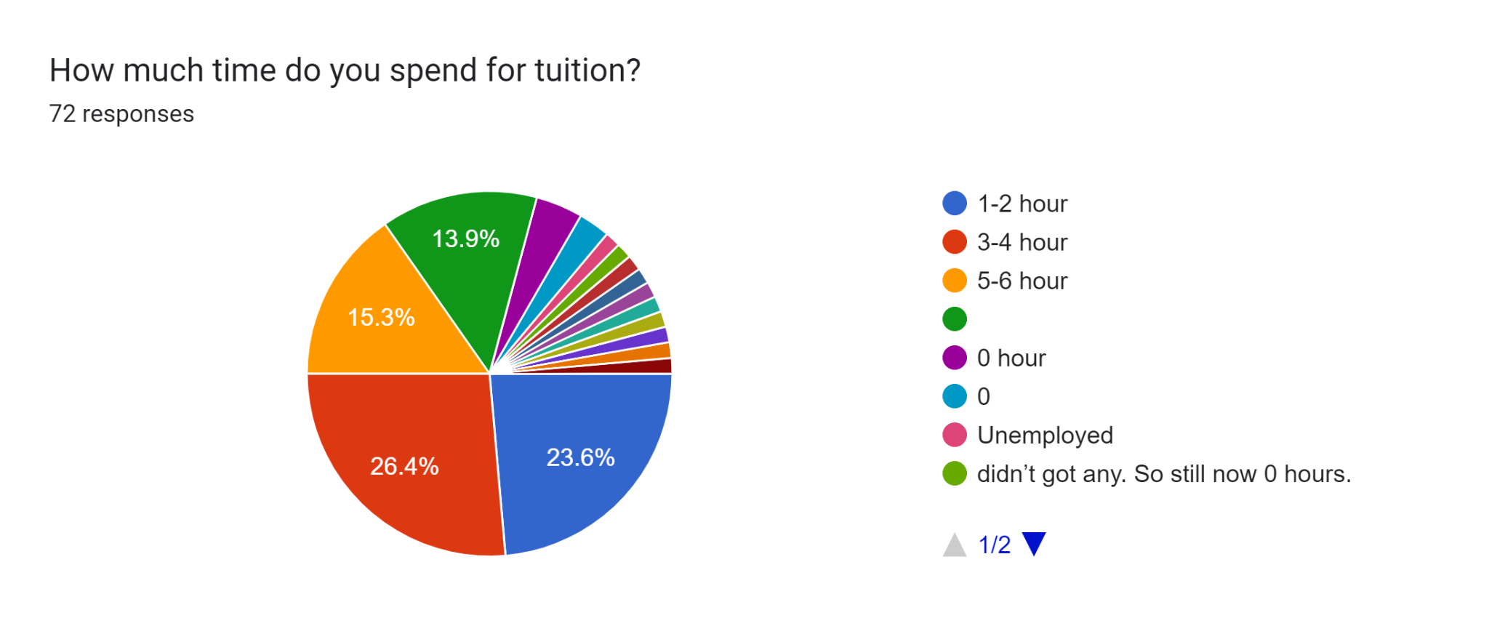

**Loans for education:**

Here maximum students do not take any loans for their education. Only 5.8% students take loans for their education. On other side 94.2% students do not take any loans for their education.

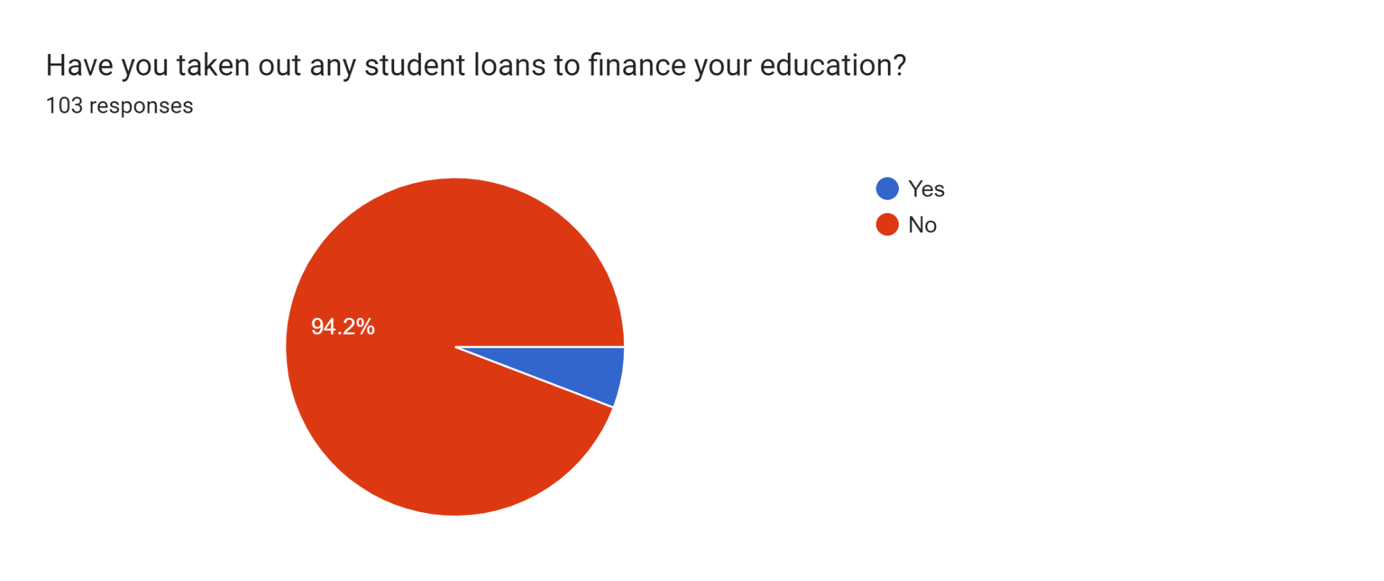

**Comparison of Public and Private University:**

In this question maximum students believe that private university offers better educational resources and facilities compared to public university. Here almost 60% student believe this. Only 30% students do not agree with this question. And 14% students are confused.

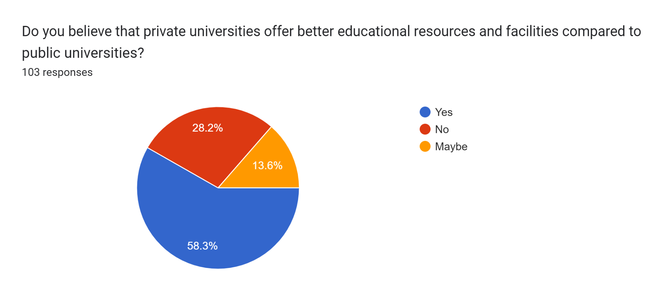

**Conclusion:**

This survey report sheds light on the educational expenditure of students in public and private universities. It is evident that the financial aspects of education are a significant concern for students, irrespective of the type of institution they attend. Policymakers, universities, and organizations should collaborate to address these concerns and ensure that students have access to affordable and quality higher education.

**Reference:**

Abdelkhalek, T., & Arestoff, F. (n.d.). *A Microeconometric Analysis of Households Saving Determinants in Morocco*.

Dasgupta, S., Hossain, Md. M., Huq, M., & Wheeler, D. (2014). *Climate Change, Soil Salinity, and the Economics of High-Yield Rice Production in Coastal Bangladesh*. The World Bank. https://doi.org/10.1596/1813-9450-7140

Easaw, J., Golinelli, R., & Malgarini, M. (2013). What determines households inflation expectations? Theory and evidence from a household survey. *European Economic Review*, *61*, 1–13. https://doi.org/10.1016/j.euroecorev.2013.02.009

Islam, M., Jamil, M., Chowdhury, M., Kabir, M., & Rimi, R. (2020). Impacts of cyclone and flood on crop and fish production in disaster prone coastal Bhola district of Bangladesh. *International Journal of Agricultural Research, Innovation and Technology*, *10*(1), 40–55. https://doi.org/10.3329/ijarit.v10i1.48093

Korzeniowska, A. M., & Ulman, P. (2023). Household saving motives and socio-demographic factors. *Ruch Prawniczy, Ekonomiczny i Socjologiczny*, *85*(4), 177–197. https://doi.org/10.14746/rpeis.2023.85.4.09

Pannell, D. J. (2010). *Policy for climate change adaptation in agriculture*.

Szopiński, T. (2017). THE DETERMINANTS OF HOUSEHOLD SAVINGS IN POLAND. *Acta Scientiarum Polonorum. Oeconomia*, *16*(2), 117–125. https://doi.org/10.22630/ASPE.2017.16.2.24